Lesson 14A: Modeling Relationships with a Line
Classwork
Example 1: Using a Line to Describe a Relationship
Best-Fit Lines (median):
- A best-fit line is a line that best represents the data and passes close to most of the data points.
- The best-fit line equation is written the same way as an equation for a line.
- A best-fit line shows a strong correlation if the data points come close to, or lie on the line,
- A weak correlation if the data points do not come close to the line.

Basketball The table below lists the number of shots attempted and number of shots made by each of the eleven members of a basketball team. Make a scatter plot of the data and answer the questions below.

x  Shots attempted | y  Shots made
240  200  135  80  75  35  20  12  10  15  20 | 160  120  50  50  70  20  10  5  7  5  0

1. Do the points graphed seem to fall on a line?

2. Is there a negative, positive, or no correlation
between the variables?

3. Draw a best-fit line and write the equation for that line.

Step 1: Name two points that lie on the line.
(Make sure they are points from the original data)

Step 2: Find the slope.

Step 3: Use the Slope-Intercept Form (y = mx + b)
to write the equation of the line.
Example 2: Using a Line to Describe a Relationship
Kendra likes to watch crime scene investigation shows on television. She watched a show where investigators used a shoe print to help identify a suspect in a case. She questioned how possible it is to predict someone’s height is from his shoe print.
To investigate, she collected data on shoe length (in inches) and height (in inches) from 10 adult men. Her data appear in the table and scatter plot below.

x = Shoe Length y = Height  12.6 74  11.8 65  12.2 71  11.6 67  12.2 69  11.4 68  12.8 70  12.2 69  12.6 72  11.8 71 | 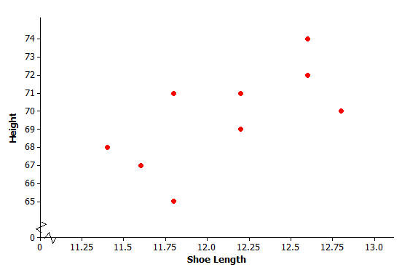

- Is there a relationship between shoe length and height?

- How would you describe the relationship? Do the men with longer shoe lengths tend be taller?

3. Draw a trend line that best represents the data.

4. Write the equation for that line.

Step 1: Name two points that lie on the line.
(Make sure they are points from the original data)

Step 2: Find the slope.

Step 3: Use the Slope-Intercept Form (y = mx + b)
to write the equation of the line.

When two variables $x$ and $y$ are linearly related, you can use a line to describe their relationship. You can also use the equation of the line to predict the value of the $y$-variable based on the value of the $x$-variable.
For example, the line $y=25.3+3.66x$ might be used to describe the relationship between shoe length and height, where $x$ represents shoe length and $y$ represents height. To predict the height of a man with a shoe length of 12, you would substitute 12 in for $x$ in the equation of the line and then calculate the value of $y$:
$$y=25.3+3.66x=25.3+3.66(12)=69.22$$
You would predict a height of $69.22$ inches for a man with a shoe length of $12$ inches.
5. Suppose that you do not know this man’s height, but do know that his shoe length is 11.8 inches. If you use the model $y=25.3+3.66x$, what would you predict his height to be?

6. Now use the equation we came up with to predict the man’s height.

7. Suppose that you know this man’s height to be 54inches, but do not know his shoe length. If you use the model $y=25.3+3.66x$, what would you predict his shoe length to be?

8. Now use the equation we came up with to predict the man’s shoe length.

Three correlations of scatter plots

Positive correlation | Negative correlation | No correlation
x and y values are related as  x increases,  y increases | x and y values are related as  x increases,  y decreases. | x and y values are not related and are said to be independent.

Lesson 14B: Modeling Relationships with a Line Using the Graphing Calculator
To use a graphing calculator to make the scatter plot for a set of data follow the steps below.
Steps to follow:
1. From the home screen, press STAT, enter to access the stat editor.
- If there are already numbers in L1, clear the data from L1 by moving the cursor to “L1” and pressing CLEAR, ENTER.
- Move the cursor to the first element of L1, type the first data value, and press enter. Continue entering the remaining data values to L1 in the same way.
- Move the cursor to the next column L2 type the first data value, and press enter. Continue entering the remaining data values to L2 in the same way. (these are your ordered pairs)
- Press 2ND, y=, 1, enter, enter
- Move the cursor to select the scatter plot diagram and press enter. Xlist: L1, Ylist: L2, choose your mark
- Set your window to the appropriate values and graph.
8. To get a best fit line press STAT move cursor to CALC, choose 4, linReg(ax +b), enter. Press 2nd STAT. Select1:L1 press “,” Then 2nd STAT again select 2: L2 press enter, enter again.
9. STAT move cursor to CALC choose 8, enter, VARS Y-VARS enter, enter, enter again, GRAPH, Then go to y =.
x  Shots attempted | y  Shots made
240  200  135  80  75  35  20  12  10  15  20 | 160  120  50  50  70  20  10  5  7  5  0

Men’s shoe length and Height Basketball shots attempted vs shots made
x = Shoe Length | y = Height
12.6 | 74
11.8 | 65
12.2 | 71
11.6 | 67
12.2 | 69
11.4 | 68
12.8 | 70
12.2 | 69
12.6 | 72
11.8 | 71

Equation _________________________
Equation________________________

Example 1
- Kendra wondered if the relationship between shoe length and height might be different for men and women. To investigate, she also collected data on shoe length (in inches) and height (in inches) for 12 women. Construct a scatter plot of these data.

$x$ = Shoe Length (Women) | 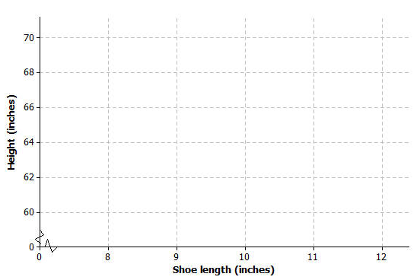  $y$ = Height (Women)
8.9 | 61
9.6 | 61
9.8 | 66
10.0 | 64
10.2 | 64
10.4 | 65
10.6 | 65
10.6 | 67
10.5 | 66
10.8 | 67
11.0 | 67
11.8 | 70

- Is there a relationship between shoe length and height for these 12 women?

- Find the equation of the least-squares line. (Round values to the nearest hundredth.)

- Suppose that these 12 women are representative of adult women in general. Based on the least-squares line, what would you predict for the height of a woman whose shoe length is 10.5 inches? What would you predict for the height of a woman whose shoe length is 11.5 inches?

- One of the women in the sample had a shoe length of 9.8 inches. Based on the regression line, what would you predict for her height?

